Laboratory WORK REPORT №1

«Simple semiconductor device circuits design and simulation»

(Includes Practice 1 Report)

**Principles of Circuits**

Student:

Program of Automation/ of Computer Science and Technology

ITMO ID: 375334

HDU ID:22320404

Name Surname:Li Xin

Link to upload: <https://forms.yandex.com/cloud/6500ee1702848f28e1856a23/>

Work purpose: to study parameters of semiconductor elements and basis of the semiconductor device design

Goals:

1) Design rectifier model on the basis of diode «diode name»

2) Simulate rectifier scheme and analyze dependencies of DC voltage ripple from load and filter capacitor values variation

3) Simulate overvoltage and overcurrent states (optional)

# Starting data

### Parameters of the voltage source:

* One-phase sine voltage source
* Rectifier scheme: Central tap rectifier (CTR)
* Source voltage amplitude

$V_{s}$ = 95 (V)

* Source voltage frequency

f= 255 (Hz)

### Diode: (copy the 1stand the second line of .lib file of your variant)

### Required parameters of DC output:

* Load resistance:

RL = RLOAD_HWR/CTR/FBR =380 (V)

* DC link filter capacitor:

Creal =560uF

# **Simulation report**

## Simulation model

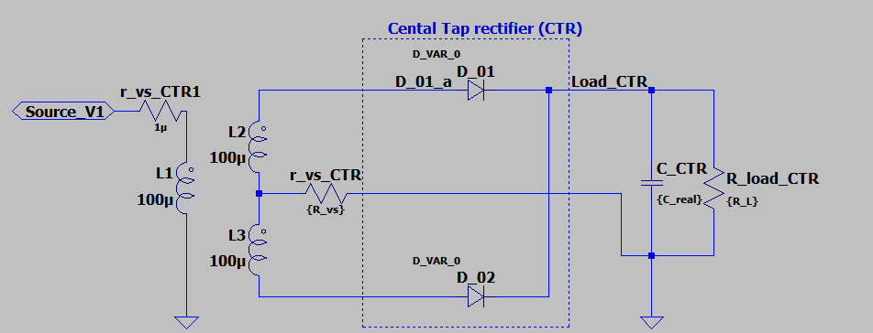

Fig. 2.1 – Rectifier scheme model

## Simulation results

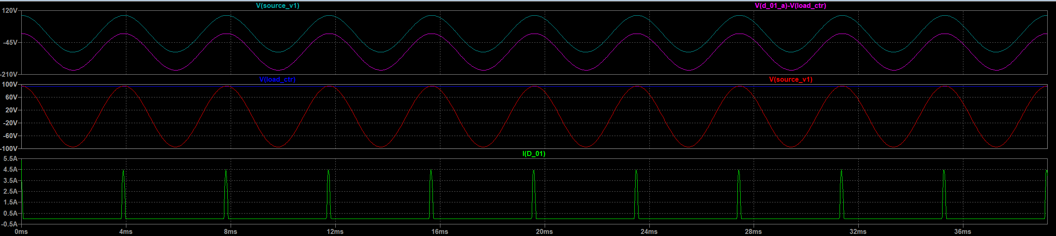

a)

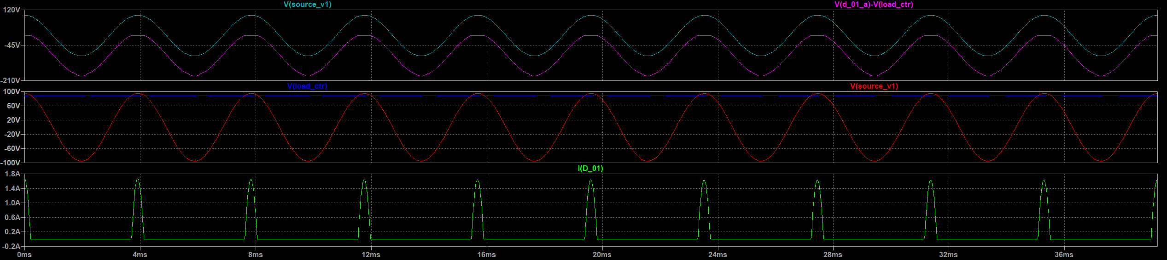

b)

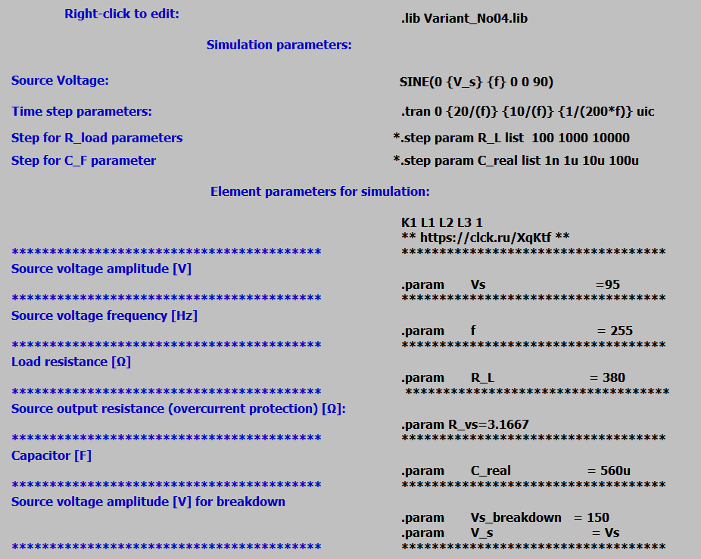

Fig 2.2 – Simulation results a) with the reverse voltage breakdown b) changed diode and fixed starting current breakdown (r_vs = 3.1667)

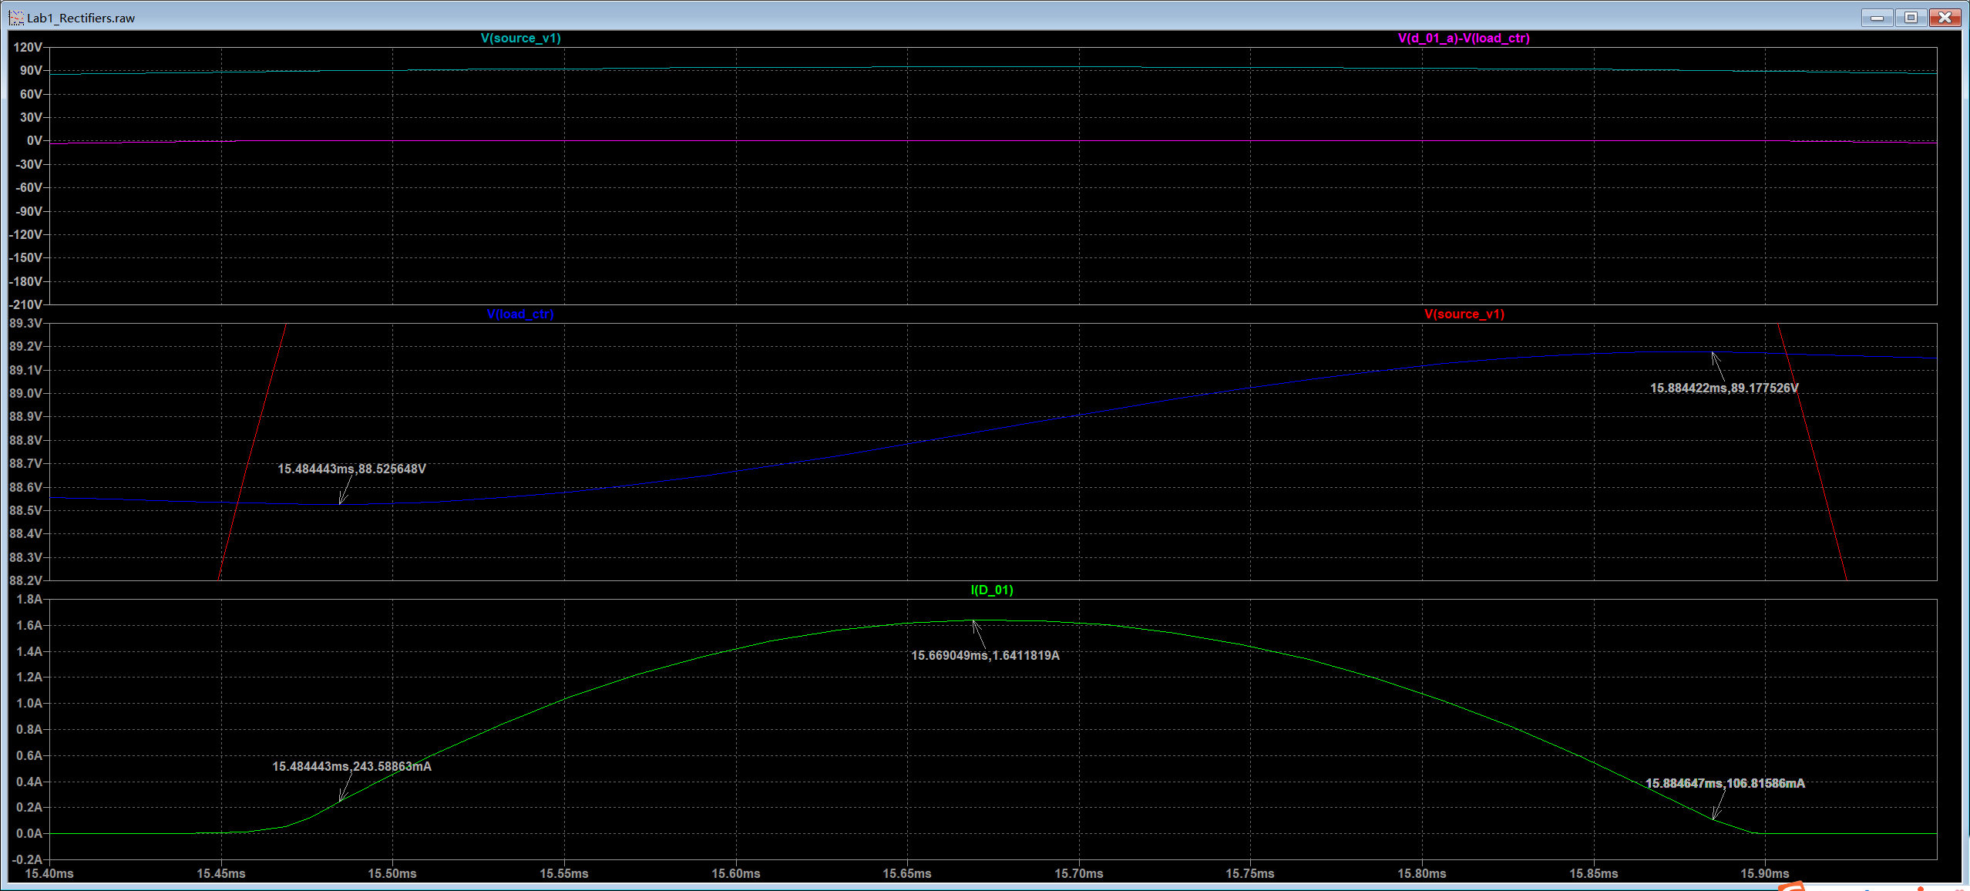

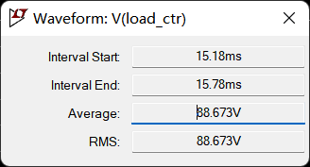

a)

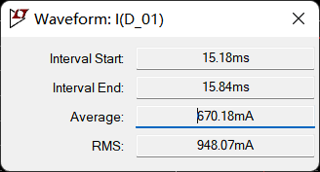

b)

Fig 2.3 –a)Voltage ripple analysis b)Diode current

To define Average and RMS values use CTRL+left click mouse button on the signal name. Use 2-3 Voltage periods in the end of simulation interval

Right-click with mouse on the signal name gives access to the signal cursor

### Voltage ripple from simulation results

$V_{{R_{L}}_{AVG}}=$ 88.673 (V)

$V_{{R_{L}}_{RMS}}=$ 88.673 (V)

$V_{{R_{L}}_{max}}=$ 89.1775 (V)

$V_{{R_{L}}_{min}}=$ 88.5256 (V)

$ΔV_{R_{L}exp}=V_{{R_{L}}_{max}}−V_{{R_{L}}_{min}}=$ 0.6519 (V)

### Ripple factor

$K_{Pexp}=\sqrt{{\left(\frac{V_{R_{L}_RMS}}{V_{{R_{L}}_{AVG}}}\right)}^{2}−1}=$ 0

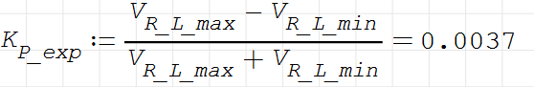

Diode opening state angle:

$τ_{1}=$ 399.979 us (s)

$θ_{exp}=τ_{1}∙f∙2π=\frac{τ_{1}}{T}∙2π$ =0.6409 (rad)

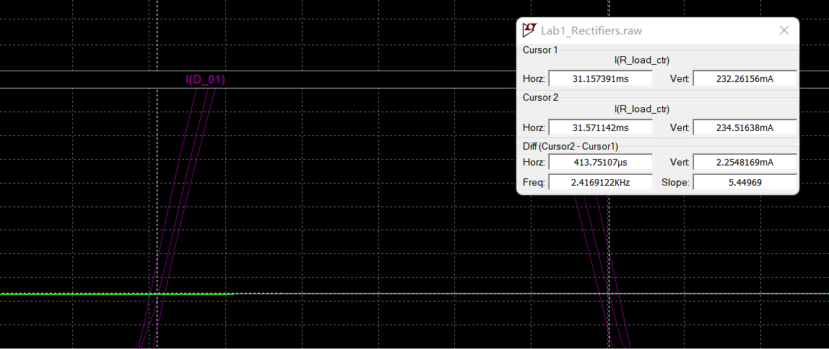

Fig 3.4 – $θ_{exp}$ angle definition from simulation results(It is recommended to consider diode open state at current level 0.05-0.1A or determine theta on the capacitor charging interval)

### Average rectifier scheme diode current (*To define Average and RMS values use CTRL+left click mouse button on the signal name. Use 2-3 Voltage periods in the end of simulation interval*)

$I_{VDexp}=670.18mA$ (A)

### Starting (Non-repetitive) maximum peak surge diode current in rectifier scheme

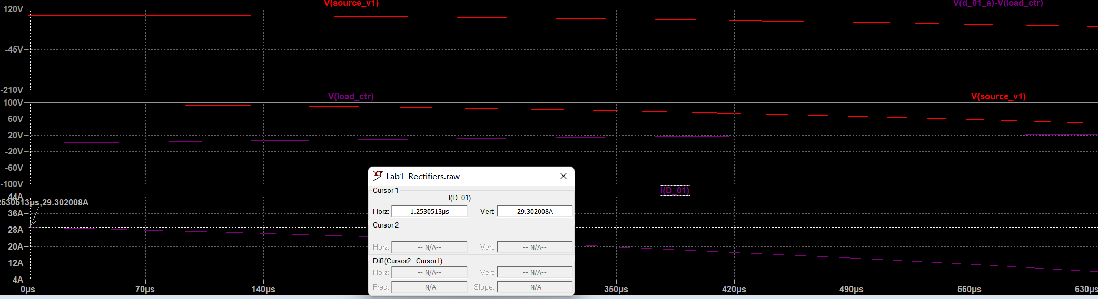

Fig 2.5 –Starting current

$I_{{VD}_{ON}exp}=$ 29.30 (A)

### 

Fig.4.3 – Capacitor parameters

Pay attention to maximum tolerance rating: for the example in this case M= 20%

Tolerance

$M=20$ (%)

$C_{real}^{ }≥\frac{C}{\frac{100\%−M}{100\%}}=1,25C$ (F)

Choose new capacitor value if it is needed.

$\frac{100\%−M}{100\%}C_{real}^{ }≥C=$ (F)

### After the nominal value is chosen:

$C_{real}^{ }$ =0.000560 (F)

$\frac{100\%−M}{100\%}C_{real}^{ }$ =0.000448 (F)

$\frac{100\%+M}{100\%}C_{real}^{ }$ =0.000672 (F)

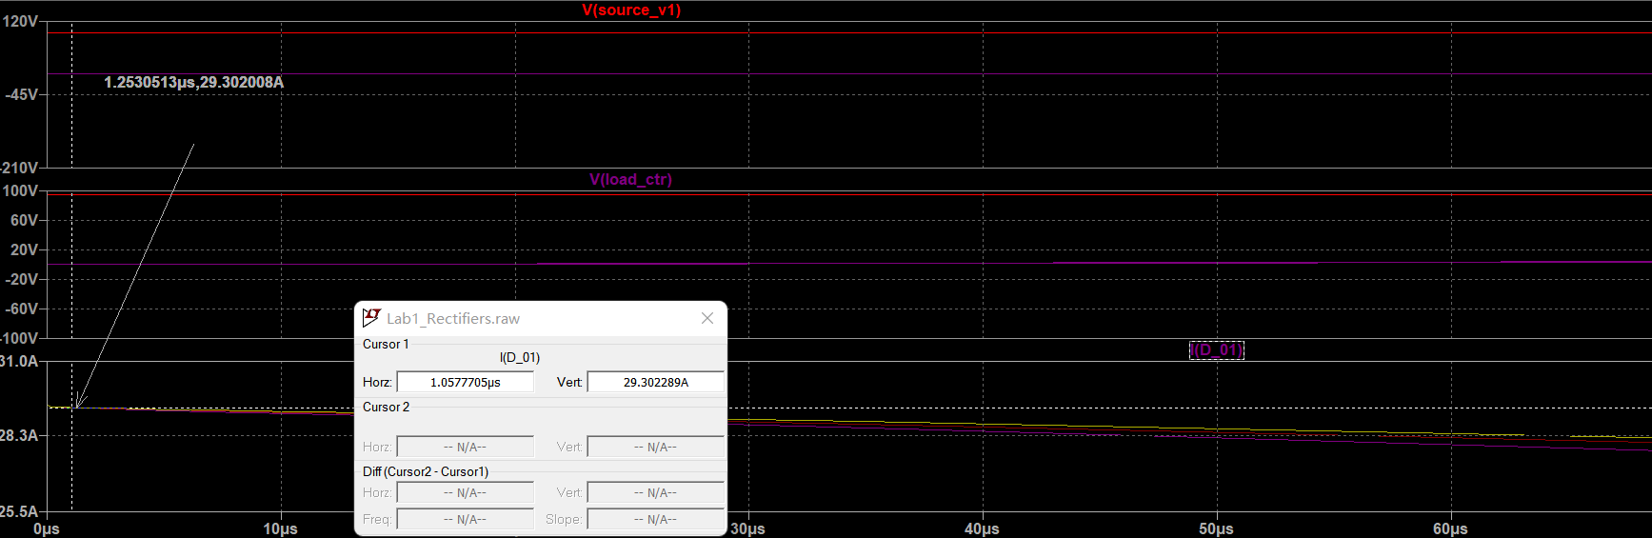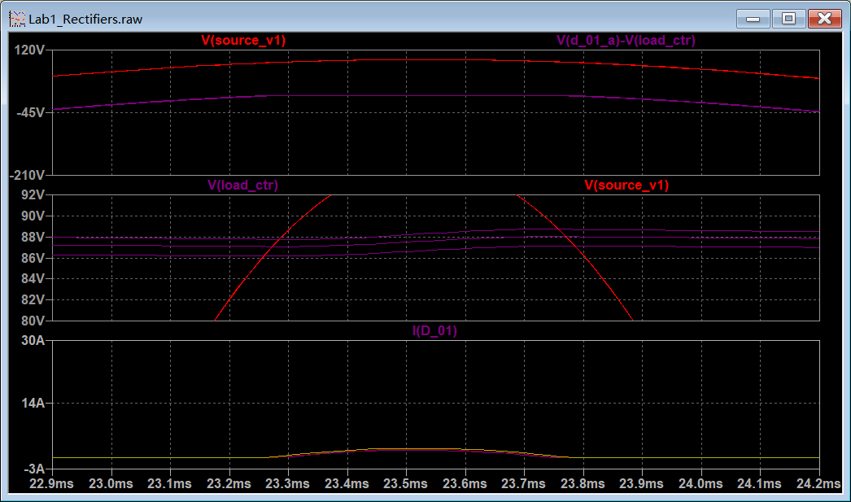

# Conclusions

1) Diode check results:

* Is breakdown voltage check passed? /Is voltage source changed because of overvoltage?
  + Passed, as the report shows that the diode handles the simulated reverse voltage condition without breakdown.
* Is starting current check passed? /Is additional resistance r_vs added to prevent overcurrent in diode/capacitor?
  + Passed.The initial peak current reached 29.30 A, and an additional resistance rvs=3.1667 Ω was added to prevent excessive current in the diode and capacitor.

2) Capacitor information: nominal value, tolerance, allowed current

· Nominal Value: 560 µF

· Tolerance: ±20%

· allowed current:1.67A

1. Provided ripple factor value

0.0037

# Appendix А.

### MUR550APFG

|  |
| --- |
|  |
|  |
|  |
|  |

Fig.1. Diode parameters for 25⁰C

# Appendix В. VariantNo04.lib listing